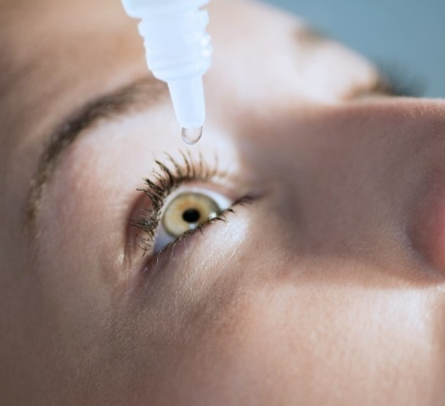
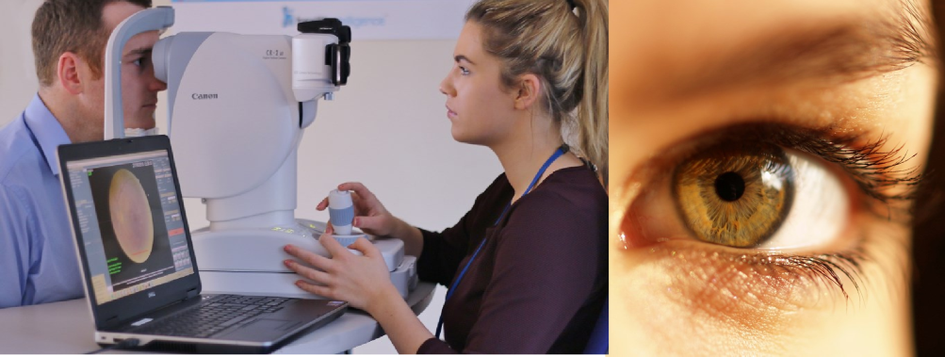
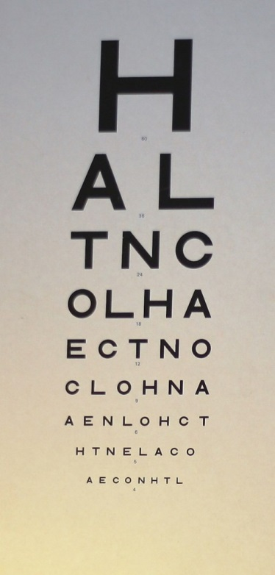
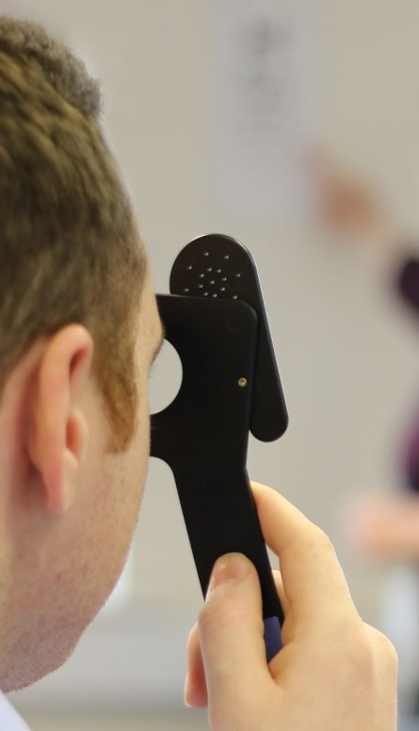
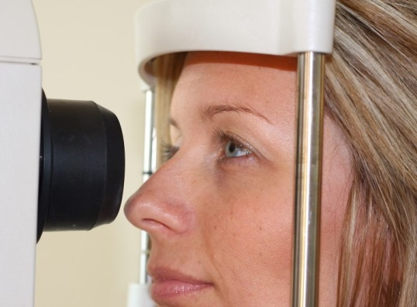
Your GP Practice works with the Hampshire & Isle of Wight Diabetic Eye Screening Programme (DESP), who will access your data if diabetes is indicated in your record. Here’s how your personal data is used:

Hampshire and Isle of Wight Diabetic Eye Screening Programme
What personal data do we collect about you and where from?
Information from your eye screening appointment (results and images), your GP Practice and the Hospital Eye Service will be used to assist in your ongoing care. The DESP can access your full name, NHS number, gender, date of birth, ethnic group, phone numbers, correspondence address, GP Practice details along with details of your diabetes care.

Who do we share your personal data
with?
The DESP keeps information about you and
For further information please speak to your GP or go to www.desphiow.co.uk

your diabetes care to ensure we maintain an accurate register and deliver a safe and effective service. NHS England have commissioned Health Intelligence to run the local service as part of the national programme. Data security arrangements protect your privacy and ensure that your data is only accessed by your Retinal
Screener and healthcare professionals involved in your care. This data is only kept for the period of the contract.
Who has access to your personal data? The DESP engages Yakara Ltd, an appointment reminder voice messaging
service and Synertec Ltd, a letter dispatch service to support the programme. Access is only for a short period of time to allow telephone calls, letter printing and dispatch to occur.

The Practice shares your diabetes related data with the Diabetic Eye Screening Programme operated
by Health Intelligence (commissioned by NHS England). This supports your invitation for eye
screening (where you are eligible and referred by the Practice) and ongoing care by
the screening programme. This data may be shared with any Hospital Eye Services you are
under the care of to support further treatment and with other healthcare professionals involved
in your care, for example your Diabetologist.

For further information, take a look at Health Intelligence’s Privacy Notice on the diabetic eye screening website: www.desphiow.co.uk

